Meeting notes
Matrix parent item ID: to group the item group we are trying to convert.
Matrix item options: they will be generated after.
Converted from: After generated, it will set this parameter to the original existing item ID, for example 9442.
Saved search: the criteria is that matrix parent item custom ID is not empty.

Matrix item name template:
{itemid}-{size}-{color}
Add a checkbox to item to have an idea if it’s a parent data or not.

Item conversion needs to be done, and after that we have to do a search for old items and their equivalent new items. First, we have to update current open transactions by removing the old item and putting the new item. Next step, remove the inventory on the old item using ‘inventory adjustment’, setting inventory to 0, and add the inventory to the new item using another ‘inventory adjustment’.
Migrate inventory items that are standalone.

Add a button or something somewhere, so we press it and then it runs the script which adjusts the inventory.
Run an inventory adjustment that removes that 20 out of the old item, and we take that new item and add that 20 to that.
One of them would have a negative value for the item adjustment, and other will have a positive value for item adjustment.

Methodology
In this example, we have to create an inventory adjustment record.
Transactions -> Inventory -> Adjust inventory:
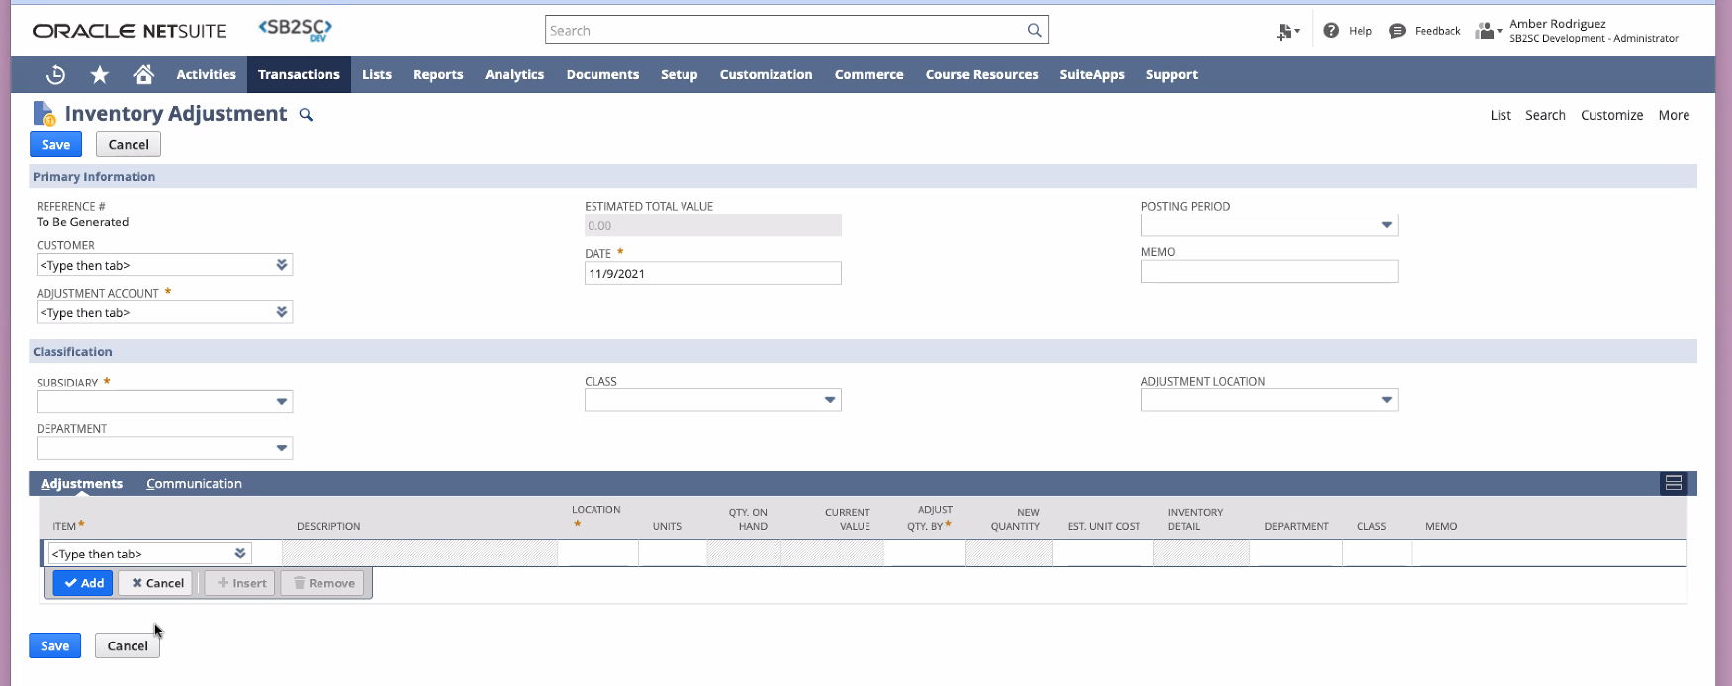
We use a scheduled script (https://4766750-sb1.app.netsuite.com/app/help/helpcenter.nl?fid=section_4387799491.html&whence=) to create that kind of record.
Create a new inventory adjustment record with create record. Use this guide to follow how to implement the script with sublists.
https://4766750-sb1.app.netsuite.com/app/help/helpcenter.nl?fid=section_4675625458.html&whence=#subsect_1517632031
And also, we use the next record:
https://system.netsuite.com/help/helpcenter/en_US/srbrowser/Browser2021_1/script/record/inventoryadjustment.html
Then we insert a line for 1 item, and a second line for the second item.
Inside this 2 lines, we “create” this 2 new sublists:
We fill up the fields item, adjust quantity by and location (these 3 are needed).
Setup -> Company -> Locations
We add two items there.

Where do we add this button for creating the inventory adjustment, where is it going to be this UI?
And to create this new record, what type of record we create? I think is more like a really technical question.
A saved search is going to give us all the values that we need.
Add it to a button to execute the scheduled script. We use this guide on scheduled script for that:
https://4766750-sb1.app.netsuite.com/app/help/helpcenter.nl?fid=section_1508948664.html

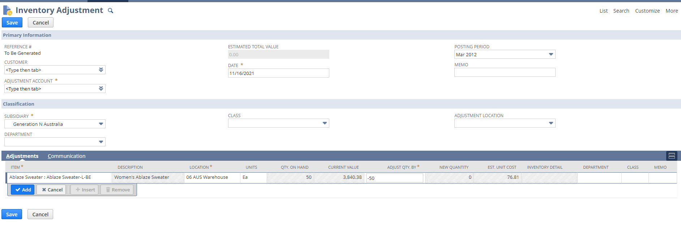
I have to replicate this steps, also with a second item.

Create a Script -> Create deployment -> Save
Then edit the deployment record and click “Save and execute”
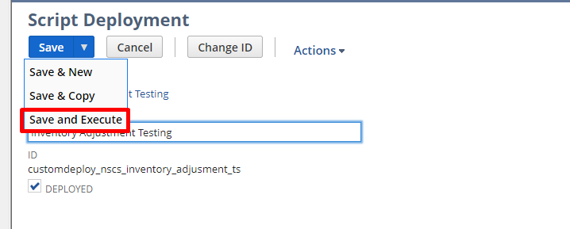

Use this saved search:
https://tstdrv2056183.app.netsuite.com/app/common/search/searchresults.nl?searchid=685&saverun=T&whence=
Also use saved search loading with N/search:
Search.load

Problema con la subsidiary:
Me pasan una subsidiary 1 que se matchea con la locación 1.
Luego subsidiary 2 que se matchea locación 2.
Entonces, si la saved search tiene 2 lineas, una con locación 1 y otra con locación 2, y me pasan la subsidiary 1, entonces el script debería fallar con la locación 2 pero seguir tranquilamente, con un try catch se arregla (try – catch en)
o mejor, no preguntar al customer por la subsidiary, buscar la locación y hacer un join con la subsidiary, agregar.

Asunciones:
El segundo item de la primera linea, tiene serial number, y no solo bin number, es por esto que falla.
Matrix Lot Numbered Item : Matrix Lot Numbered Item-BE has serial number, and not only bin number.
Los dos items se tendrian que corresponder, es decir si uno tiene bin number solo los dos deberian tener bin number
solos, y lo mismo para serial numbers
sino habria que agregar un segundo serial number y un segundo bin number.
en issue inventory number algo esta mal porque me esta dando error.
Sospecho que para los bin numbers tambien necesitamos otro, para la parte del segundo item, capaz
se necesita otro no el campo binnumber.

